Table Creation:
Create table Students (Name varchar2(30), Course varchar2(10), DOB Date, Contact Number(10), email varchar2(40));
Insert Values to table:
Insert into Students values ('Prem','JAVA','10-OCT-2000',9787878787,'xyz@gmail.com')
Insert into Students (Name , Course, DOB, Contact) values (‘Ajay’,’SQL’,’10-SEP-2000’,9787878787)
Insert Multiple records in single statement:
Begin
Insert into Students(Name,Course,DOB,Contact) values ('Ajay','SQL','10-SEP-2000',978784287);
Insert into Students(Name,Course,DOB,Contact) values ('Vijay','SQL','10-SEP-2000',97845787);
Insert into Students(Name,Course,DOB,Contact) values ('Vinay','SQL','10-SEP-2000',977854787);
end;
Select statements:
Select * from Students
Select Contact, Course from Students

Operators:
An operator is a reserved word or a character used primarily in an SQL statement's WHERE clause to perform operation(s), such as comparisons and arithmetic operations. These Operators are used to specify conditions in an SQL statement and to serve as conjunctions for multiple conditions in a statement.
- Comparison operators
- Logical operators
- Arithmetic operators
- Concatenation operator
- Set operators
Comparison operators:
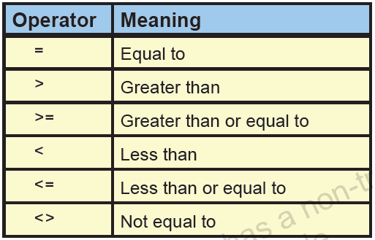
Between and, Like, IN, IS NULL, IS NOT NULL, EXISTS
NOT EqualTo - To fetch records which are not equal to mentioned value
Select * from employees where department_id!=20;
Select * from employees where department_id<>20;

Lesser Than: To fetch records which are lesser than mentioned value
Select * from employees where Salary < 4000;
Greater Than: To fetch records which are greater than mentioned value
Select * from employees where Salary > 4000;
Equal to: To fetch records which are equal to mentioned value
Select name, id, age, salary from employees where salary=24000;
Between_And: To fetch records which are having values between the mentioned range of two values
Select * from employees where salary between 1500 and 5000;
Like – Used to fetch the records which are having given values in any part in the value in the record of the column.
Select * from employees where last_name like 'Kin%'
Select * from employees where last_name like '%in%'
IS NULL: To fetch records which are having NULL values in particular columns
Select * from employees where commission_pct is null
IS NOT NULL: To fetch records which are not having NULL values in particular columns
Select * from employees where commission_pct is not null
Exists:
Select * from employees e Where exists(select * from departments d where employee_id=department_id)
Employees Dept
Name, id ,age, c_num dept_id, dept_name
Arun 1 1 Development
Veera 4 4 Testing
Revathi 6 8 Testing

Logical Operators:
AND, OR, NOT
AND- To fetch records satisfying two conditions
Select * from employees where first_name = 'Valli' and salary=4800
OR- To fetch records satisfying any one or both of the mentioned conditions
select * from employees where employee_id=100 or department_id=100
NOT- To fetch records which are not having particular value in the column.
select * from employees where job_id not in ('FI_MGR','IT_PROG')
select * from employees where name not in(‘Revathi’, ‘Valli’)
Arithmetic operators:
+, -, * ,/
ADD- Select emp_name,salary+1000 from employees;
SUBTRACT- Select first_name,salary-1000 from employees;
MULTIPLY- Select first_name, salary monthlysalary,salary*12 as annualsalary from employees;
DIVIDE- Select first_name,salary/3 from employees;

Concatenation Operator:
Displays the result of two columns joined as a single string using the sysmbol ‘||’
Select first_name||last_name from employees
or result can be displayed with desired text message between the column values as below.
Select first_name||’is working as ‘|| job_id from employees
Quote Operator- q operator:
Quote operator can be used used the literal itself has a quotation mark in it.
Select department_name||q'[ department’s Manager Id is: ]'|| Manager_id from departments

SET operators:
UNION

Displays all records selected by both queries excluding the duplicate records.
select employee_id, job_id, department_id from employees
UNION
select employee_id, job_id,department_id from job_history

UNION ALL
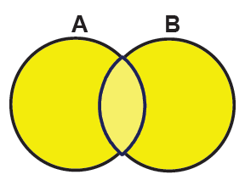
Displays all records selected by both the query and it shows including the duplicate rows.
select employee_id, job_id, department_id from employees
UNION ALL
select employee_id, job_id,department_id from job_history

INTERSECT
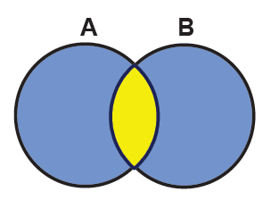
Displays all common records selected by both queries.
select employee_id, job_id, department_id from employees
INTERSECT
select employee_id, job_id,department_id from job_history

MINUS
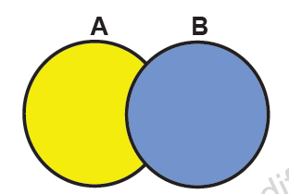
All records fetched in the first statement and not select in second statement
select employee_id, job_id, department_id from employees
MINUS
select employee_id, job_id,department_id from job_history

